# STRUCTURAL HEALTH MONITORING SYSTEM

## A REPORT

**On**

**Inter Departmental Project of III B. Tech. II Semester**

By

# V.Subhash

191FA03015,Civil

# G.Pushyami

191FA07044,IT

# K.Sarmistha

191FA07048,IT

# Y.Pavithra

191FA07060,IT

# B.Kamal

191FA03004,Civil



# DEPARTMENT OF INFORMATION TECHNOLOGY 2021-2022



**DECLARATION**

We hereby declare that the inter departmental project report entitled “STRUCTURAL HEALTH MONITORING SYSTEM” submitted to the Department of Information Technology, Vignan’s Foundation for Science, Technology and Research, Deemed to be University. This report is the work done by us in the Department of Information Technology by collaborating with the department of Civil Engineering.

**Place:**

**Date:**

**Signature of Student**



**CERTIFICATE**

This is to certify that the Inter Departmental Project Report entitled “STRUCTURAL HEALTH MONITORING SYSTEM” is being submitted by G.Pushyami, K.Sarmistha, Y.Pavithra, B.Kamal, V.Subhash in partial fulfillment for the award of B. Tech Degree in Information Technology at Vignan’s Foundation for Science, Technology and Research, Deemed to be University It is a record of bonafide work carried out by them in Department of Information Technology, Vignan’s Foundation for Science Technology and Research under the supervision of Mr. P.Ramadoss.

**Signature of Project Guide Signature of HOD**

**External Examiner**



**ACKNOWLEDGEMENTS**

Inter department project is an opportunity to work collaboratively with other departments such as ECE, EEE, Automobile, Bio Technology, Food Technology etc., students and helps in gaining knowledge in other department domains.

We express our gratitude towards the Management for providing opportunity to work and implement inter department projects.

It is a great pleasure for us toexpress our sincere thanks to Prof. K. V. Krishna Kishore, HOD, IT of VFSTR Deemed to beUniversity, for providing me an opportunity to do Inter department project. We feel it our responsibility to thank Mr.P.Ramadoss under whose valuable guidance that the project came out successfully after each stage.

We extend our wholehearted gratitude to all our faculty members of Department of Information Technology who helped us in our academics throughout course.

Finally, we wish to express thanks to our family members for the love and affection overseas and forbearance and cheerful depositions, which are vital for sustaining effort, required for completing this work.

V.Subhash(191FA03015)

With Sincere regards,

G.Pushyami(191FA07044) K.Sarmistha(191FA07048) Y.Pavithra(191FA07060) B.Kamal(191FA03004)

# CONTENTS

|  |  |  |
| --- | --- | --- |
| **S.NO.** | **DESCRIPTION** | **PAGE NO.** |
|  | **ABSTRACT** | **6** |
| **1** | **INTRODUCTION** | **7-8** |
| **2** | **PROJECT DESCRIPTION** | **9** |
| **3** | **SOURCE CODE** | **10-12** |
| **4** | **METHODOLOGY** | **13-14** |
| **5** | **RESULT** | **15** |
| **6** | **CONCLUSION** | **16** |
|  | **REFERENCES** | **17** |

**ABSTRACT**

In the current fast developing nations the infrastructure is the major point to be taken challenging for the development of the country in this aspect many building that are excellent in asthetic view are now getting demolished and the health of the structure are getting decreased day by day due to environmental impacts and the global warming is the one of the biggest reason for damage of many structures so in order to revive those structures the health of those structure is measured, and then suitable retrofitting method is suggested for the problem. The current project gives the basic idea of identifying the damage in the structure using low powered sensor modules and using machine learning.

# INTRODUCTION

Any structure including civil, aerospace and mechanical engineering possess some health in terms of strength with respect to the age that health need to be monitored and necessary prognosis need to be done for the safe economical growth and the sustainable development. The machine learning techniques are now widely involved in the structural health monitoring these days the machine learning technique is divided in to two types based on the input data one is image based and the other is vibration based. The image based structural health monitoring uses digital trees and neural networks and other regressional analysis to classify the damage presence and type of the damage in the structure. Whereas in the vibrational input the algorithm uses some formula and the strength and the deflections are being monitored and gives output.

And the usage of low power sensors and microcontrollers takes the project to a better extent so the Arduino microcontrollers and the sensors made this project in giving basic idea of damage. The introduction to components is as following :

## 1.2Arduino microcontroller

Basically Arduino is a platform in which the students and electronic hobbiests and others can do their projects using some hardware consisting of microcontrollers and other boards.

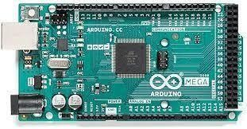

The board that shown in the image is caller Arduino microcontroller. The set of instructions in caliberate the sensors and the to retrive the sensor data is givenby a computer using a programmable medium(c here).

## 1.13SENSORS

1. **ULTRA SONIC SENSOR DISTANCE MEASURING MODLE**

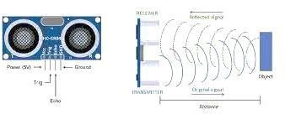The ultrasonic sensor is used to send the ultrasonic pulses into concrete member and to measure the velocity in that concrete medium the velocity in that concrete gives the quality of that concrete.

## ACCELEROMETER SENSOR

The accelerometer sensor gives the deflection and vibrations in a structure using this sensor the visual deflections are found from the structural element.

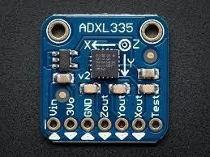

## 1.2 Machine learning applications

The current project uses the edge detecting library in the python language the use of this library to detect the sharp edges in the flat 2d images, the application of that module is made use in detection of the crack in structural health monitoring.

# PROJECT DESCRIPTION

This experimental procedure defines the structural health monitoring and the usage of low powered sensors to find the quality of concrete and the vibrations from the concrete. This project also involves a crack detection automation written in python programming language. In this automation the computer takes the input as a picture format and gives the crack pattern. Where as in the other part the sensor finds the vibrations from the concrete element and gives the tilt along 3 coordinate axis. The strategy involved in finding the quality of strength is Ultra sonic pulse velocity test. Here a ultrasonic sensor is being implanted to a structural element in 3 different manners called direct semi direct and indirect transmissions and get the velocity through the concrete and compared to the table of values given in **IS 13377 part 1** to know the quality of concrete This is the overall aim and the work involved in this project.

# SOURCE CODE

# -*- coding: utf-8 -

*-"""

Created on Sat Apr 9 08:54:28 2022 @author: SUBHASH

"""

import cv2 import math

import numpy as np import scipy.ndimage

def orientated_non_max_suppression(mag, ang): ang_quant = np.round(ang / (np.pi/4)) % 4 winE = np.array([[0, 0, 0],[1, 1, 1], [0, 0, 0]])

winSE = np.array([[1, 0, 0], [0, 1, 0], [0, 0, 1]])

winS = np.array([[0, 1, 0], [0, 1, 0], [0, 1, 0]])

winSW = np.array([[0, 0, 1], [0, 1, 0], [1, 0, 0]])

magE = non_max_suppression(mag, winE) magSE = non_max_suppression(mag, winSE) magS = non_max_suppression(mag, winS) magSW = non_max_suppression(mag, winSW)

mag[ang_quant == 0] = magE[ang_quant == 0] mag[ang_quant == 1] = magSE[ang_quant == 1] mag[ang_quant == 2] = magS[ang_quant == 2] mag[ang_quant == 3] = magSW[ang_quant == 3]return mag

def non_max_suppression(data, win):

data_max = scipy.ndimage.filters.maximum_filter(data, footprint=win, mode='constant')

data_max[data != data_max] = 0 return data_max

# start calulcation

gray_image = cv2.imread(r'C:/Users/SUBHASH/OneDrive/Desktop/crack.jpg', 0) with_nmsup = True #apply non-maximal suppression

fudgefactor = 1.3 #with this threshold you can play a little bitsigma

= 21 #for Gaussian Kernel

kernel = 2*math.ceil(2*sigma)+1 #Kernel size gray_image = gray_image/255.0

blur = cv2.GaussianBlur(gray_image, (kernel, kernel), sigma) gray_image = cv2.subtract(gray_image, blur)

# compute sobel response

sobelx = cv2.Sobel(gray_image, cv2.CV_64F, 1, 0, ksize=3) sobely = cv2.Sobel(gray_image, cv2.CV_64F, 0, 1, ksize=3)mag = np.hypot(sobelx, sobely)

ang = np.arctan2(sobely, sobelx)

# threshold

threshold = 4 * fudgefactor * np.mean(mag) mag[mag < threshold] = 0

#either get edges directly if with_nmsup is False:

mag = cv2.normalize(mag, 0, 255, cv2.NORM_MINMAX)kernel = np.ones((5,5),np.uint8)

result = cv2.morphologyEx(mag, cv2.MORPH_CLOSE, kernel) cv2.imshow('im', result)

cv2.waitKey()

#or apply a non-maximal suppression else:

# non-maximal suppression

mag = orientated_non_max_suppression(mag, ang)# create mask

mag[mag > 0] = 255

mag = mag.astype(np.uint8) kernel = np.ones((5,5),np.uint8)

result = cv2.morphologyEx(mag, cv2.MORPH_CLOSE, kernel) cv2.imshow('im', result)

cv2.waitKey()

# METHODOLOGY

## MACHINE LEARNING

The procedure obtained in our experimentation is quite conventional, the structural health monitoring is done in two phases using. Low powered tools. The first one is to identify the crack on the wall and the second one is to monitor the crack depth, concrete strength and the quality of the concrete. The steps we adapted for the first half is to collect the suspected area to be monitored in the picture format, the picture can be taken in any angle but in good lighting condition the input for the machine learning algorithm or the machine learning technique is a high quality or medium quality image of a crack. Then after taking the image as input the computer will convert the data into different types like vector data representation or raster data model, the data is now arranged in the order then the image interpretation is done based on the interpretation key color and contrast and the brightness as the interpretation keys. Every pixel is compared with the neighbouring pixel and the dark pixel in image gets more darker and the white pixel gets more whiter. In doing so the whole image will gets its threshold brightness value thus highlighting the darker part of the image. So ultimately giving the crack pattern.

But before giving the image input to the algorithm the data, the data to be cleaned and then given to the algorithm, hence this step is called cleaning the data. The working of the algorithm is done using python as a programming language and imported several useful libraries. From the web Actually the python program used here is intended to make the sobel edge detection for fonts and all the application of that algorithm is the present technique to identify the crack.

## VIBRATIONAL METHOD

In this method the sensors are arranged in three methods direct transmissionor semi direct transmission or the indirect transmission.

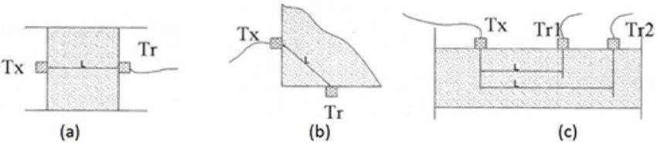

The arrangement of sensors and are connected to circuit consisting of Arduino and computer and then data fetching is started.

# TEST CASES

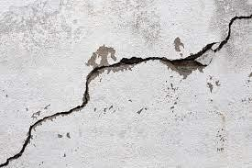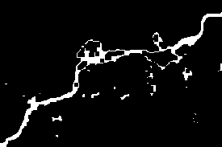

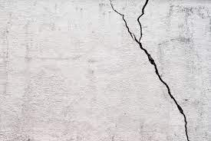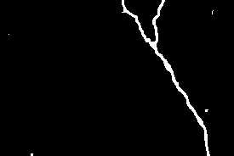

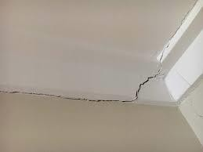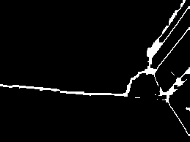

1. **CONCLUSION**

In the final the conclusion of the project is that the structural health monitoring can be achieved by the low powered sensors and can have very basic and accurate results from the structure we can also say that the calibrated modules can give much more accuracy which is very much necessary. The live structure can be even tested and can trust the results.

# REFERENCES

IS code: IS13311 part 1 Data sheet HC-SR-04

Farrar, Charles R., and Keith Worden. "An introduction to structural health monitoring." *Philosophical Transactions of the Royal Society A: Mathematical, Physical and Engineering Sciences* 365, no. 1851 (2007):

303-315.

Müller, Adrien, Nikos Karathanasopoulos, Christian C. Roth, and Dirk Mohr. "Machine Learning Classifiers for Surface Crack Detection in Fracture Experiments." *International Journal of Mechanical Sciences* 209 (2021): 106698.

Smarsly, Kay, Kosmas Dragos, and Jens Wiggenbrock. "Machine learning techniques for structural health monitoring." In *Proceedings of the 8th European workshop on structural health monitoring (EWSHM 2016), Bilbao, Spain*, pp. 5-8. 2016.

Sohn, Hoon, Charles R. Farrar, Francois M. Hemez, Devin D. Shunk, Daniel W. Stinemates, Brett R. Nadler, and Jerry J. Czarnecki. "A review of structural health monitoring literature: 1996–2001." *Los Alamos National Laboratory, USA* 1 (2003).